AWS PROJECT 1

Deploying A High Availability web application and Bastion host in AWS

Step 1:

Creating a VPC

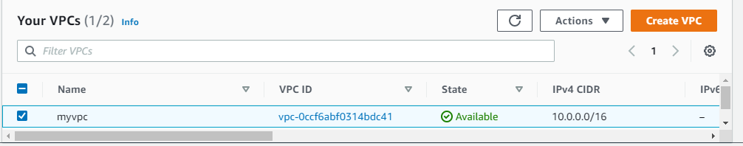

Step 2:

Creating a Internet Gateway and attach to VPC

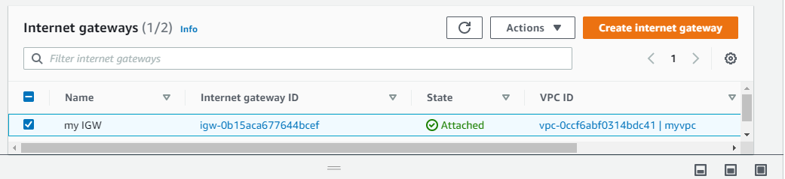

Step 3:

Creating a public and private Subnets

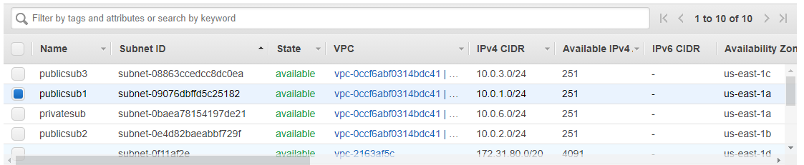

Step 4:

Creating a Rout table and add IGW route and assigning to Public subnet

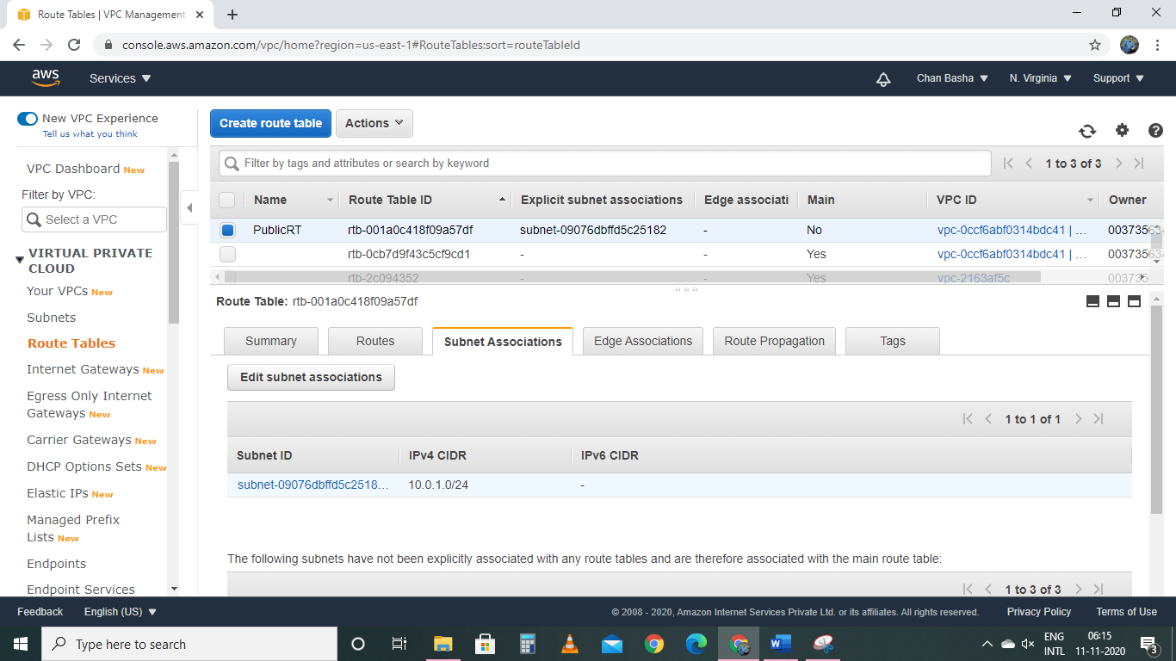

Step 5:

Creating a Bastion server

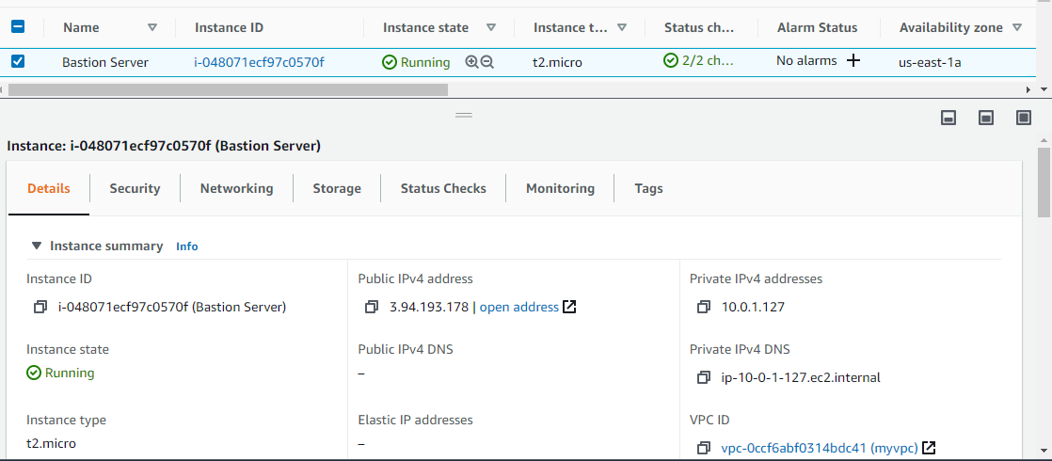

Step 6:;

Creating a two web application servers in private subnet

Webserver1

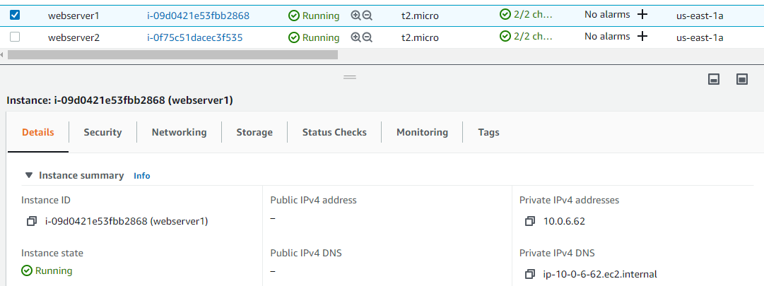

Webserver2

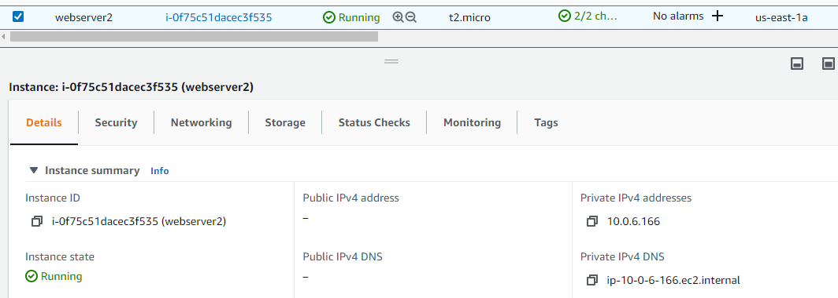

Step 7:

Creating a load Balancer

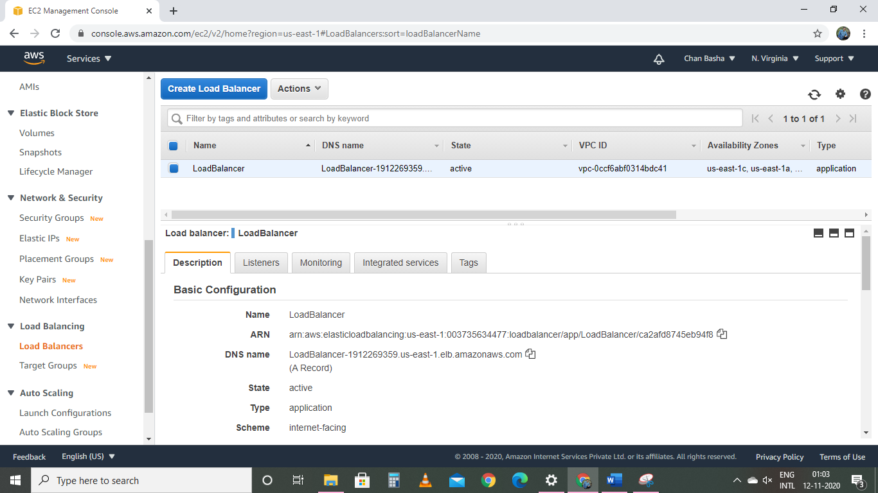

Step 8:

Creating a NAT Gateway in public subnet

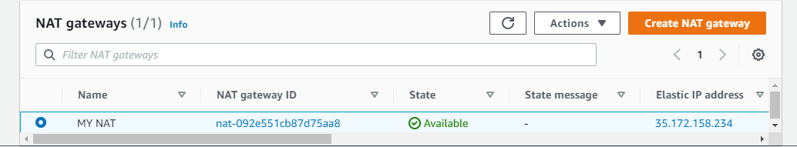

Step 9:

Launching a Bastion server and adding private key in folder

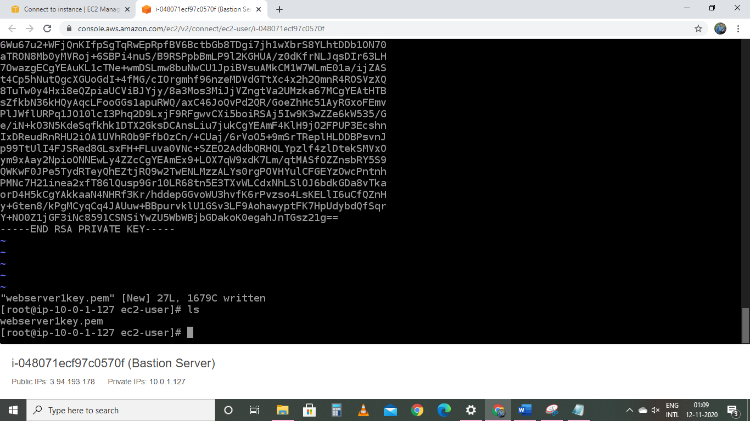

Step 10: Launching into webserver1 with Bastion server and installing apache

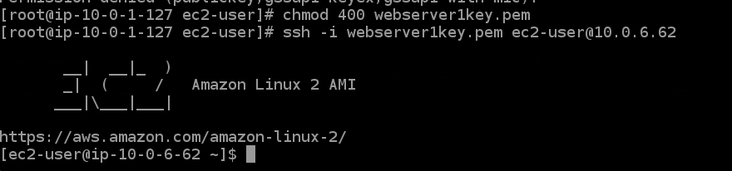

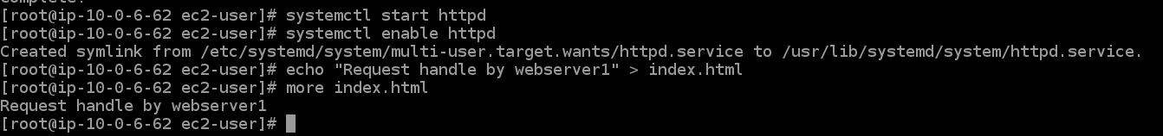

Step 11: Launching webserver2 with bastion server

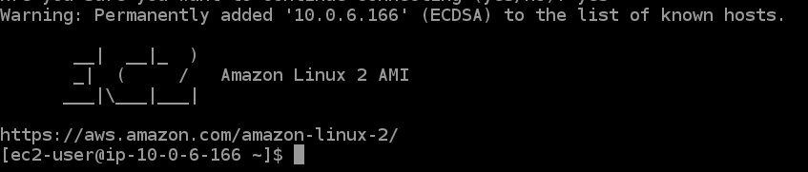

Step 12: Using load balancer DNS

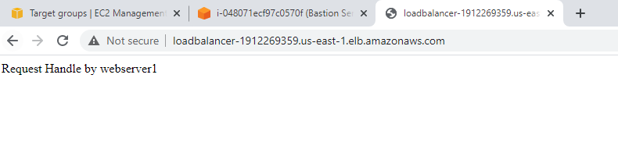

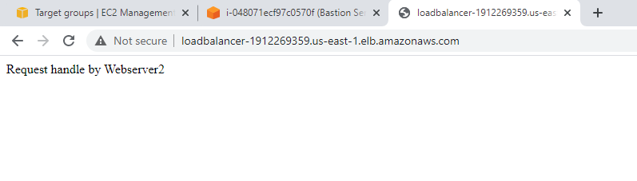

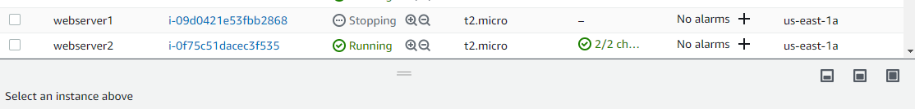

Checking High Availability

Step 13: making webserver1 down and checking with load balance DNS

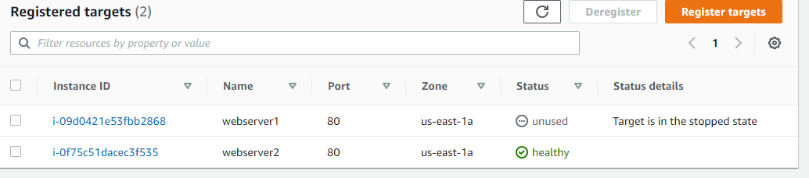

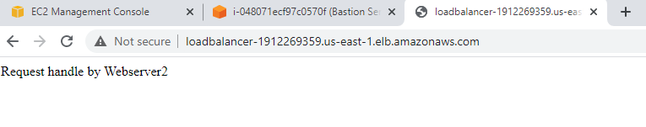

Step 14: Making webserver2 stopped and checking with Load balancer DNS

